**Top 10 Pig:**

**On Grunt:**

HotelGroup = GROUP Hotelreviews BY Hotel_Name;

HotelAverage = FOREACH HotelGroup {

A = ORDER Hotelreviews BY Average_Score DESC;

B = LIMIT A 1;

GENERATE FLATTEN(group), FLATTEN(B.Average_Score);

};

OrderData = ORDER HotelAverage by Average_Score DESC;

Top10 = LIMIT OrderData 10;

Store Top10 INTO 'PigTop10';

**Screen shots of Query Execution:**

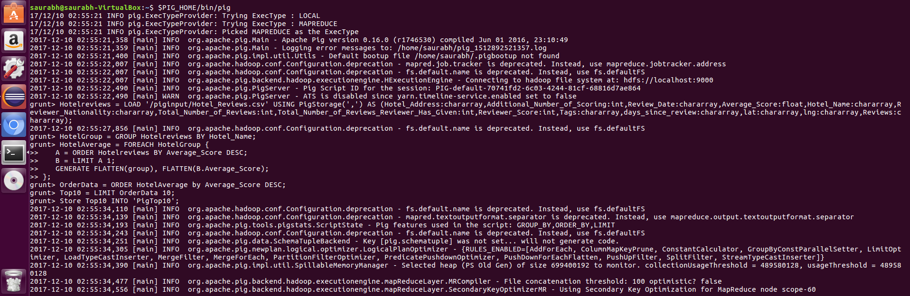

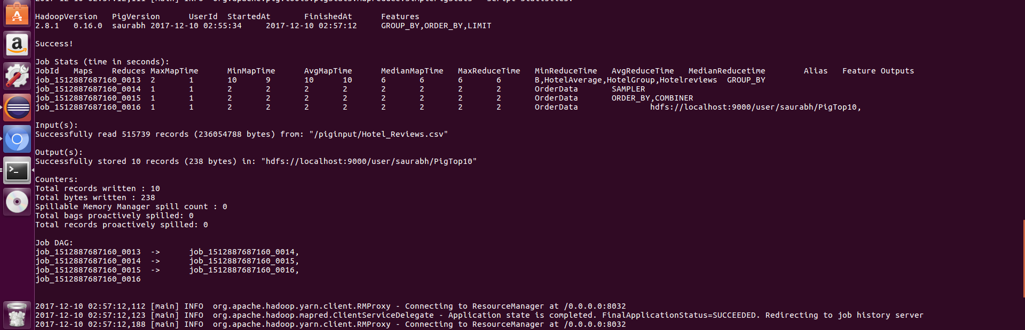

**Output:**



On Hadoop with Query file:

